**DAILY ONLINE ACTIVITIES SUMMARY**

|  |  |  |  |  |  |  |
| --- | --- | --- | --- | --- | --- | --- |
| **Date:** | **29-05-2020** | | | **Name:** | **Vandana E V** | |
| **Sem & Sec** | **8th sem A sec** | | | **USN:** | **4AL15CS103** | |
| **Online Test Summary** | | | | | | |
| **Subject** | | **BDA** | | | | |
| **Max. Marks** | | **30** | | **Score** | **19** | |
| **Certification Course Summary** | | | | | | |
| **Course** | **Python for machine learning** | | | | | |
| **Certificate Provider** | | | **Great Learning Academy** | **Duration** | | **5Hrs** |
| **Coding Challenges** | | | | | | |
| **Problem Statement**:Given an array arr[] of size N and an integer K.The task is to find the last remaining element in the array after reducing the array. | | | | | | |
| **Status: completed** | | | | | | |
| **Uploaded the report in Github** | | | | **yes** | | |
| **If yes Repository name** | | | | **Vandana** | | |
| **Uploaded the report in slack** | | | | **yes** | | |

Online Test Details:



Certification Course Details:

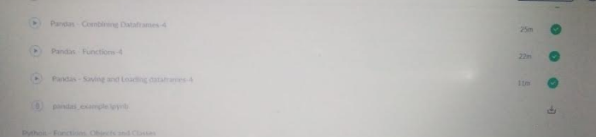

**Online Coding Challenge :**

Program 1

void moreThanNdK(int arr[], int n, int k)

{

// k must be greater than 1 to get some output

if (k < 2)

return;

/* Step 1: Create a temporary array (contains element

and count) of size k-1. Initialize count of all

elements as 0 */

struct eleCount temp[k-1];

for (int i=0; i<k-1; i++)

temp[i].c = 0;

/* Step 2: Process all elements of input array */

for (int i = 0; i < n; i++)

{

int j;

/* If arr[i] is already present in

the element count array, then increment its count */

for (j=0; j<k-1; j++)

{

if (temp[j].e == arr[i])

{

temp[j].c += 1;

break;

}

}

/* If arr[i] is not present in temp[] */

if (j == k-1)

{

int l;

/* If there is position available in temp[], then place

arr[i] in the first available position and set count as 1*/

for (l=0; l<k-1; l++)

{

if (temp[l].c == 0)

{

temp[l].e = arr[i];

temp[l].c = 1;

break;

}

}

/* If all the position in the temp[] are filled, then

decrease count of every element by 1 */

if (l == k-1)

for (l=0; l<k; l++)

temp[l].c -= 1;

}

}

/*Step 3: Check actual counts of potential candidates in temp[]*/

for (int i=0; i<k-1; i++)

{

// Calculate actual count of elements

int ac = 0; // actual count

for (int j=0; j<n; j++)

if (arr[j] == temp[i].e)

ac++;

// If actual count is more than n/k, then print it

if (ac > n/k)

cout <<"Number:"<< temp[i].e

<<" Count:"<< ac << endl;

}

}